CARBON
BEHAVIOUR OBJECTIVES
At the end of this lesson, students should be able to:
- prepare a list of 10 natural substances used daily that contains carbon.
- locate the position of carbon in the periodic table and write its electronic configuration.
- discuss the concept of allotropy, allotropes of carbon and give 3 uses of each of the allotropes of carbon.
- enumerate 4 types of coal, their uses and write location of coal mines in Nigeria.
- list products of the destructive distillation of coal and describe gasification of coke.

Natural Substances Containing Carbon
- Jewellery  - Lead pencil  - Air  - Sugar  - Caustic soda | - Aspirin  - Baking soda  - Protein  - Carbohydrate  - Soda drinks

Carbon is a non-metal element that occurs naturally as diamond and graphite, also in an impure form as coal, charcoal, coke as well as in the combined state as petroleum, wood and natural gases.
It also occurs in minerals as limestone (CaCO₃) and dolomite CaMg(CO₃)₂, and also in the atmosphere (air) as CO₂, which is essential for plants and animals. The chemistry of carbon compounds is known as Organic Chemistry.

POSITION OF CARBON IN THE PERIODIC TABLE
Carbon is a chemical element with the symbol C, the sixth element on the periodic table, and the first member of group 14 elements, with atomic number 6 and mass number 12. Its electronic configuration is 1s² 2s² 2p². Carbon has four valence electrons and has the ability to catenate, i.e. form four covalent bonds. It basically exhibits oxidation number +2 and +4 in its compounds.

ALLOTROPES OF CARBON
Allotropy is the property of some chemical elements to exist in two or more different forms, in the same physical state.
Carbon exhibits allotropy as it can exist in different forms but in the same physical state. Allotropes of carbon can be classified into;
- Crystalline
- Non- crystalline
In this study, consideration will be on crystalline allotropes of carbon.

Crystalline Allotropes of Carbon
The common crystalline allotropes of carbon are diamond and graphite.
Diamond: The purest form of naturally occurring carbon. Diamond crystals is octahedral in shape. It is a giant molecule in which the carbon atoms are closely packed and held together by strong covalent bonds. Artificial diamonds are made by subjecting graphite to very high pressure and temperature for several hours in the presence of a catalyst.
Graphite $\underset{→}{ \left(\text{Ni/Rh}\right)\text{high temp. \& high press. } }$ Diamond

Structure of Diamond

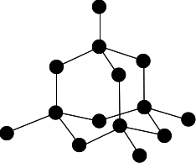
Uses
- It is used in the manufacture of glass cutters and rock breakers.
- Used as pivot support in precision instrument.
- Its high refractive index and dispersion power makes it valuable as jewellery.

Graphite: exists as black, slippery, hexagonal crystals. The carbon atoms in graphite form flat layers, which are parallel, one above the other, with weak intermolecular forces operating in-between the layers. These weak forces allow movement of the plane parallel over each other
Structure of Graphite
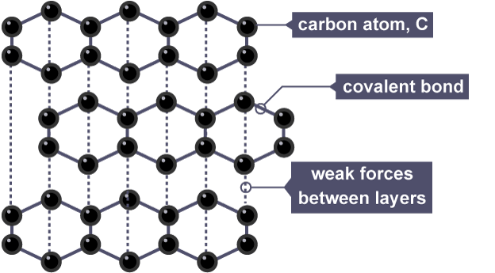

Uses
- Used as lubricants in engines.
- A mixture of graphite and clay is used in the manufacture of lead pencils.
- Used in making electrodes and black pigments in paints.

Properties of Diamond and Graphite
Diamond | Graphite
• Non-conductor of electricity  • Hardest known substance  • Colourless, transparent solid  • Density of 3.5gcm⁻³  • Octahedral in shape | • Good conductor of electricity  • Very soft  • Black, opaque solid  • Density of 2.3gcm⁻³  • Hexagonal in shape

COAL
Coal was found as a result of complex chemical and physical changes when the remains of forest were buried under the earth millions of years ago under great pressure in the absence of air. Coal is an impure form of carbon, containing impurities like nitrogen, ssulphur, phosphorus, hydrogen, oxygen. States where coal are mined in Nigeria are Enugu, Delta, Kogi, Nasarawa, Adamawa.

Types of Coal
They vary in carbon content.
- Peat: about 60% of carbon.
- Lignite (brown coal): about 70% of carbon.
- Bituminous (soft coal): about 85% of carbon.
- Anthracite (hard coal): about 95% of carbon.

Uses of Coal
- Lignite coal is used as fuel for steam.
- Bituminous coal is used in the production of steel.
- Used as a reducing agent for briquetting charcoal.

DESTRUCTIVE DISTILLATION OF COAL
This is the process of heating coal to a very high temperature in the absence of air. It decomposes to give four main products, namely; coke, ammoniacal liquor, coal tar and coal gas.

GASIFICATION OF COKE
It is the conversion of coke to combustible gases by incomplete oxidation with either air or steam. The gases produced are;
Producer Gas: a mixture of nitrogen and carbon(II) oxide, prepared by passing air over red-hot coke in a furnace.
2C_{(s)} + O_{2(g)} + N_{2(g)} 2CO_{(g)} + N₂ + heat
It is an exothermic reaction and it is the source of nitrogen for the manufacture of ammonia during Haber Process.

WATER GAS: a mixture that contains equal volumes of carbon(ii) oxide and hydrogen. Prepared by passing steam over white-hot coke in a furnace at 1000ºC.
C_{(s)} + H₂O_{(g)} CO_{(g)} + H_{2(g)} + Heat
It is an endothermic reaction and is used in the manufacture of hydrogen, methanol and butanol.

USES OF COKE
- Used as fuel both industrially and domestically.
- It is a reducing agent in the extraction of metals from their ores.
- It is used in the production of graphite.

DRILL QUESTIONS
- The following can be obtained directly from the destructive distillation of coal except ______?
- Coal gas
- ammoniacal liquor
- tar
- producer gas

- The existence of an element in two or more form in the same physical state is known as ______?
- Hybridization
- Allotropy
- Isotopy
- Isomerism

- Which allotropes of carbon is a constituent of lead pencil ______?
- Soot
- Diamond
- Graphite
- Lampblack

- Diamond is used in making jewellery due to its ______?
- Transparency
- refractive index
- high melting point
- hardness

- When graphite is subjected to very high temperature and pressure for several hours in the presence of catalyst nickel, the product is ______?
- Artificial diamond
- Soot
- Graphite flakes
- Quartz

ANSWER
- D
- B
- C
- B
- A

